U.S. Radiocommunications Sector
Fact Sheet
Working Party: USWP7C | Document No: USWP 7C/27-043NC
Reference:  WRC-27 AI 1.17  Resolution 682 (WRC-23)  R23-WP7C-C-0142!N10!MSW-E | Date: 12 February 2025
Document Title: Working Document Toward A Preliminary Draft New Report ITU-R RS.[SW_Studies]
Author(s)/Contributors(s):  Philip Sohn  NOAA  Tomasz Wojtaszek  NOAA  Christopher Hough  NOAA  Edna Prado  NOAA  Panagiotis Efthymakis  NOAA | Phone: 301-427-9676  Email: philip.sohn@noaa.gov  Phone : 301-456-4574  Email : tomasz.wojtaszek@noaa.gov  Phone : 301-323-8212  Email : christopher.hough@noaa.gov  Phone : 301-628-5742  Email : edna.prado@noaa.gov  Phone : 804-980-4253  Email : panagiotis.efthymakis@noaa.gov
Purpose/Objective: To progress the studies that are required under the WRC-27 Agenda Item 1.17
Abstract:
This contribution seeks to progress the studies that are required under the WRC-27 Agenda Item 1.17 by providing updates and additional elements to the Working Document Toward A Preliminary Draft NEW Report ITU-R RS.[SW Studies], Annex 10 to the recent Working Party 7C meeting Chair’s Report.
Fact Sheet Preparer: Philip Sohn

Radiocommunication Study Groups | 
Source: Document 7C/TEMP/36  Subject: WRC-27 agenda item 1.17 | Document 7C/XXX-E
 | TBD
 | English only
WORKING DOCUMENT TOWARD A PRELIMINARY DRAFT NEW
REPORT ITU-R RS.[SW_STUDIES]

1 Introduction
WRC-27 agenda item 1.17 considers regulatory provisions for receive-only space weather sensors and their protection in the Radio Regulations, taking into account the results of ITU-R studies in accordance with Resolution 682 (WRC-23).

2 Related ITU-R Recommendations/Reports
Report ITU-R RS.2456 – Space weather sensor systems using radio spectrum

3 List of acronyms and abbreviations
CME Coronal Mass Ejection
HF High Frequency
ICAO International Civil Aviation Organization
MetAids Meteorological Aids Service
PCA Polar Cap Absorption

4 Spectrum needs and appropriate protection criteria

4.1 Riometers
Resolution 682 (WRC-23) identifies six frequency bands for potential MetAids (space weather) allocations, namely 27.5-28.0 MHz, 29.7-30.2 MHz, 32.2-32.6 MHz, 37.5-38.325 MHz, 73.0-74.6 MHz, and 608-614 MHz. Among them, five of these bands below 75 MHz are suitable and used for space weather sensors known as riometers (Relative Ionospheric Opacity METERs). Riometers observe ionospheric absorption events that can degrade or obscure HF communications lasting minutes to several days, potentially disrupting aeronautical communications on polar and high-latitude flights.
Empirical and theoretical prediction models based on historical data are often used to predict the intensity and spatial extent of space weather phenomena, and this is also the case for HF radio degradation caused by a solar radiation storm termed a polar cap absorption (PCA). These models help to identify patterns and correlations in space weather phenomena, allowing future events to be predicted. Riometers have been in use since the 1960s and have collected long-term and continuous observational data to date. Ensuring data continuity by consistently observing the same frequencies such as 30 MHz, 32.4 MHz and 38.2 MHz is essential for predicting space weather phenomena.
The International Civil Aviation Organization (ICAO) has provided space weather advisory information services for phenomena expected to affect aeronautical radiocommunications and radionavigation systems since 2019. Solar radiation storms can be predicted using internationally accepted models as described above. ICAO space weather advisory is issued with a description of the severity of impact in moderate (MOD) and severe (SEV) categories. For PCAs, threshold levels that trigger an advisory are defined in the ICAO Manual on space weather information as 2.0 dB for MOD and 5.0 dB for SEV using data from a typical 30 MHz riometer.
Moreover, a comparison of ionospheric absorption obtained at several observation frequencies provides information on the altitude to which solar energetic particles have penetrated. Specifically, this uses the knowledge that the amount of absorption measured by the riometer is inversely proportional to the square of the observed frequency when the altitude of intrusion of the falling energetic particles is high (> around 70 km) but deviates from the square when the altitude of intrusion is low (< around 70 km). In recent years, using this technique, spectral riometers capable of observing broadband frequencies, typically ranging 20-60 MHz but some ranging 10-80 MHz, have been deployed to estimate the spatial profile of ionospheric electron density and then the energy distribution of the precipitating electrons. Five potential frequency bands listed in Resolution 682 (WRC-23) serve this purpose.

4.2 Solar radio flux monitors and solar spectrograph systems
As explained in Report ITU-R RS.2456-1, radio flux observations in different frequencies are used to monitor the evolution and classifications of the most short-lived solar features such as solar radio bursts. Dynamic radio spectra are used to further characterize flares, CMEs and the associated shock waves through the associated types II, III, and IV radio emission signatures (see Figure 3 and Table 1 of Report ITU-R RS.2456-1). Among solar radio burst phenomena, Type II and Type IV bursts are of particular importance for space weather forecast, because Type II radio emission profiles allow estimation of shock wave propagation speeds and Type IV are considered to have a close correspondence with CMEs and proton events. The forecasts of space weather events, triggered by the occurrence of radio bursts, as well as the speed of shocks in the corona and solar wind, require the observation of dynamic radio spectra between 20 MHz and 2 GHz with a cadence of 1 to 60 seconds and a delay of availability of 1 and 5 minutes. Such measurements are obtained by ground-based infrastructure which requires contributions from observatories around the globe to achieve 24-hour coverage. In solar radio bursts, the frequencies of radio spectra emitted from a solar flare shift or broaden as time progresses from eruption in the frequency range between 20 MHz and 2 GHz. The six frequency bands listed in Resolution 628 (WRC-23) can capture the solar radio emission characterized above.

5 Propagation models and technical and operation characteristics
The Table below lists the reference documents for the propagation models and the technical and operational characteristics provided by the contributing groups.
Source | Document | Information services
WP 3L & WP 3M | 7C/88 | Propagation models
WP 4C | 7C/47 | Mobile-satellite service
WP 5A | 7C/174 | Amateur and amateur-satellite services
WP 5B | 7C/64 | Aeronautical radionavigation service  Radionavigation service
WP 5C | 7C/176 | Fixed service
WP 5D | 7C/157 | Mobile service-IMT systems
WP 6A | 7C/167 | Terrestrial broadcasting service
WP 7B | 7C/156 | Space radiocommunication applications (SOS, SRS, EESS, and Meteorological satellite service)
TBD | TBD | TBD

6 Sharing and compatibility (impact on SW receive-only sensors)
WRC-27 agenda item 1.17 is considering potential frequency allocations to the MetAids (space weather) service, limited to receive-only sensors, such that there will be no interference by these sensors into other services in the same or in adjacent frequency bands. Given that space weather sensors are receive-only systems, sharing and compatibility studies are only to focus on analysing the impact of incumbent services on receive-only space weather sensors in the frequency bands included in Resolution 682 (WRC-23), in order to assess the usability of new allocations to MetAids (space weather).
Studies analyzing impact of incumbent services on receive-only space weather sensors will be contained in the Annexes listed in the Table below. It is noted that studies are not needed for impact from the mobile-satellite service, since only a secondary allocation exists in the frequency band 608-614 MHz. Similarly, it is noted that studies are not needed for impact from the space science radiocommunication applications, since no relevant EESS or METSAT allocations currently exist, and no technical or operational characteristics can be identified for the SOS and SRS in the band 30.005-30.01 MHz.

Annex 1 | Studies analyzing impact of the amateur and amateur-satellite services on receive-only space weather sensors in the frequency bands 27.5-28.0 MHz and 29.7-30.2 MHz.
Annex 2 | Studies analyzing impact of the aeronautical radionavigation and radionavigation services on receive-only space weather sensors in the frequency bands 73.0-74.6 MHz and 608-614 MHz.
Annex 3 | Studies analyzing impact of the fixed service on receive-only space weather sensors in the frequency bands 27.5-28.0 MHz, 29.7-30.2 MHz, 32.2-32.6 MHz, 37.5-38.325 MHz, 73.0-74.6 MHz, and 608-614 MHz.
Annex 4 | Studies analyzing impact of the IMT systems on receive-only space weather sensors in the frequency band 608-614 MHz.
Annex 5 | Studies analyzing impact of the terrestrial broadcasting service on receive-only space weather sensors in the frequency bands 73.0-74.6 MHz and 608-614 MHz.

7 Notification to be included in the MIFR
This section is proposed to contain studies on possible regulatory provisions of the Radio Regulations to accommodate the possibility for an administration that desires to notify a receive-only space weather sensor station to be included in the Master International Frequency Register.

Annex 4 IMT Systems
Studies analysing impact of IMT systems on receive-only space weather sensors in the frequency band 608-614 MHz

A4.1 Introduction
This Annex contains the studies analysing impact of IMT systems on receive-only space weather sensors in the frequency band 608-614 MHz, as this is the only relevant frequency band considering the currently existing primary mobile service allocations and IMT identifications with respect to the frequency bands being studied under WRC-27 Agenda Item 1.17.
In Region 3, in accordance with the Table of Frequency Allocations and the RR 5.296A, primary mobile service allocations and IMT identifications currently exist for the frequency band 470-698 MHz (or portions thereof) in Micronesia, the Solomon Islands, Tuvalu and Vanuatu, and for the frequency band 610-698 MHz (or portions thereof) in Bangladesh, Lao P.D.R., Maldives, New Zealand and Vietnam, subject to certain agreements and restrictions. It should be noted that IMT identification for these frequency bands currently does not exist in Australia or any nearby countries.
In Region 2, in accordance with the RRs 5.297, 5.295, 5.293, 5.308, and 5.308A, primary mobile service allocations and IMT identifications currently exist for the frequency band 512-608 MHz (or portions thereof) in the Bahamas, Barbados, Canada, the U.S. and Mexico, and for the frequency band 614-698 MHz (or portions thereof) in the Bahamas, Barbados, Belize, Canada, Colombia, El Salvador, the U.S., Guatemala, Jamaica, and Mexico, subject to certain agreements and restrictions. It should be noted that IMT identifications for these adjacent frequency bands currently exist in the U.S. and the neighbouring countries.
In Region 1, in accordance with the RR 5.307A, primary mobile service allocation and IMT identification currently exist for the frequency band 614-698 MHz in Saudi Arabia, Bahrain, Egypt, the United Arab Emirates, Iraq, Jordan, Kuwait, Oman, Palestine, Qatar, and the Syrian Arab Republic, subject to certain agreements and restrictions. It should be noted that IMT identification for this frequency band currently does not exist in Italy or any neighbouring countries.
Considering these currently existing mobile service primary allocations and IMT identifications, studies will be conducted to analyze interference from IMT downlinks operating in the adjacent frequency band 614-698 MHz to the solar flux monitor operating in the U.S. (Sagamore Hill, MA).

A4.2 Technical Characteristics

A4.2.1 Solar flux monitors technical/operational characteristics used in this study
In accordance with document 7C/142, Annex 7, Section 3, a power flux density protection threshold of -164.9 dBW/(m² MHz) will be used for the receive-only solar flux monitors operating within the frequency band 608-614 MHz. Technical and operational characteristics such as receive antenna pattern, minimum elevation angle during solar tracking, and receiver frequency dependent rejection (FDR) curve will need to be established. In the meantime, an omnidirectional antenna pattern will be used to assess out-of-band emissions of IMT downlinks operational in the adjacent band will be within the power flux density threshold of currently operating solar flux monitors.

A4.2.2 IMT technical/operational characteristics used in this study
The relevant technical and operational characteristics for the terrestrial component of IMT are provided in the following documents by Working Party 5D:
- document 5D/716 (06/2021), Annex 4.4, Section 3.2.1.1, “Below 1 GHz”,
- document 5D/413 (10/2024), Annex 4.2, Section 4, “Characteristics of terrestrial component of IMT in the several frequency bands from 608 MHz to 48.2 GHz in preparation for other WRC-27 agenda items”, and
- Report ITU-R M.2292-0 (12/2013), “Characteristics of terrestrial IMT-Advanced systems for frequency sharing/interference analysis”.
Table A4.2.2-1 below provides the IMT-2020 specification related parameters for frequency bands below 1 GHz (based on Table 1 in document 5D/716 Annex 4.4 Section 3.1 “IMT-2020 specification related parameters”), and Table A4.2.2-2 below provides the IMT deployment-related parameters for frequency bands below 1 GHz (Tables 4-1 and 4-2 in document 5D/716 Annex 4.4 Section 3.2.1.1).

Table A4.2.2-1: IMT-2020 specification related parameters below 1 GHz
No. | Parameter | Base station  (non-AAS) | Mobile station
1 | Duplex Method | FDD  See (1), § 5.2.  (Note X) | FDD  See (2), § 5.2.  (Note X)
2 | Channel bandwidth (MHz) | See (1), § 5.3.5  (Note X) | See (2), § 5.3.5  (Note X)
3 | Signal bandwidth | Derived from channel bandwidth, see (1), § 5.3.2.  Signal bandwidth = N_{RB} × SCS × 12. | Derived from Channel bandwidth, see (2), § 5.3.2.  Signal bandwidth = N_{RB} × SCS × 12.
4 | Transmitter characteristics
4.1 | Power dynamic range (dB) | Depends on Channel bandwidth,  See (1), § 6.3.3, Table 6.3.3.2-1. | See (2), § 6.2.1  (UE max output power) and § 6.3.1 (UE min output power, depends on Channel bandwidth).
4.2 | Spectral mask (dB) | Category A:  See (1),  § 6.6.4.2.1 (Wide Area BS), § 6.6.4.2.3 (Medium Range BS), § 6.6.4.2.4 (Local Area BS).  Category B (Note Z):  See (1), § 6.6.4.2.2 (Wide Area BS), § 6.6.4.2.3 (Medium Range BS), § 6.6.4.2.4 (Local Area BS).  (Note Y) | See (2), § 6.5.2.2, Table 6.5.2.2-1.
4.3 | ACLR | See (1), § 6.6.3.2, Table 6.6.3.2-1. | See (2), § 6.5.2.4.1.
4.4 | Spurious emissions | Category A:  See (1), § 6.6.5, Table 6.6.5.2.1-1.  Category B (Note Z):  See (1), § 6.6.5, Table 6.6.5.2.1-2 | See (2), § 6.5.3.1.
4.5 | Maximum output power | Deployment specific – see section 3.2.1 | See (2), § 6.2.1,  Table 6.2.1-1.  (Note X)
5 | Receiver characteristics
5.1 | Noise figure (dB) | 5 dB (Macro cell scenario)  10 dB (Micro cell scenario)  13 dB (Indoor small cell scenario)  (Note Y) | 9 dB
5.2 | Sensitivity (dBm) | Depends on channel bandwidth and BS class, see (1), § 7.2.2. | Depends on operating band, see (2), § 7.3.2, Table 7.3.2-1.
5.3 | Blocking response | See (1), § 7.5.2, Table 7.5.2-1 and § 7.4.2, Tables 7.4.2.2-1, 7.4.2.2-2 and 7.4.2.2-3. | Depends on operating band, see (2), § 7.6, Tables 7.6.2-2 and 7.6.2-4, 7.6.3-2 and 7.6.3-4 for blocking levels.
5.4 | ACS | See (1), § 7.4.1.2. | See (2), § 7.5, Tables 7.5-1 and 7.5-2.
5.5 | SINR operating range (dB) | See below “SINR operating range and mapping function”
Note X: Typical values of duplex method, channel bandwidth and max output power for both non-AAS and AAS IMT stations in different frequency bands are provided in Section 3.2.1.
Note Y: Wide Area Base Stations are characterised by requirements derived from Macro Cell scenarios, Medium Range Base Stations are characterised by requirements derived from Micro Cell scenarios and Local Area Base Stations are characterised by requirements derived from Pico Cell scenario, see (1), § 4.4.
Note Z: Category B limits are limits defined and adopted by some countries (see Recommendation ITU-R SM.329) and could be used for compatibility analysis if required for specific deployments.
References used in the Table (The excerpts of these references are available in the Annexes of this document.):
(1) 3GPP TS 38.104 v.16.6.0 (2020-12), “NR; Base Station (BS) radio transmission and reception”.
(2) 3GPP TS 38.101-1 v.16.6.0 (2020-12), “NR; User Equipment (UE) radio transmission and reception; Part 1: Range 1 Standalone”

Table A4.2.2-2: Deployment-related parameters for bands below 1 GHz
 | Urban/suburban macro | Rural macro
Base station characteristics/Cell structure
Cell radius | 0.5-5 km (typical value to be used in sharing studies for urban macro 1.5 km and for suburban macro 3 km) | > 5 km (typical value to be used in sharing studies 8 km)
Antenna height | 30 m | 30 m (see Note 1)
Sectorization | 3 sectors | 3 sectors
Down tilt | 3 degrees | 3 degrees
Frequency reuse | 1 | 1
Antenna pattern | Recommendation ITU-R F.1336 (recommends 3.1)  k_{a} = 0.7  k_{p} = 0.7  k_{h} = 0.7  k_{v} = 0.3  Horizontal 3 dB beam width: 65 degrees  Vertical 3 dB beam width: determined from the horizontal beam width by equations in Recommendation ITU-R F.1336. Vertical beam widths of actual antennas may also be used when available.
Antenna polarization | Linear/±45 degrees | Linear/±45 degrees
Below rooftop base station antenna deployment | Urban: 20%  Suburban: 0% | 0%
Feeder loss | 3 dB | 3 dB
Typical channel bandwidth | 10 MHz | 10 MHz
Maximum base station output power (Report ITU-R M.2292) | 46 dBm in 10 MHz | 46 dBm in 10 MHz
Maximum base station antenna gain (Report ITU-R M.2292) | 15 dBi | 15 dBi
Maximum base station output power/sector (e.i.r.p.) | 58 dBm in 10 MHz | 58 dBm in 10 MHz
Network loading factor (base station load probability X%) (see Section 3.4 below and Rec. ITU-R M.2101 Annex 1, section 3.4.1 and 6) | 20%, 50% | 20%, 50%
TDD / FDD / SDL | FDD / SDL | FDD / SDL
Note 1: In macro rural cases in various regions, typical antenna heights could vary depending on the notion of rural territory, i.e. population density, actual distribution of settlements, infrastructure availability, etc.

Per Recommendation ITU-R M.2101, the IMT network modeling will use the macro cell geometry shown in Figure 1, where each hexagon represents a 120-degree azimuth coverage area for each base station (BS) sector, and A and B represent the IMT cell radius and inter-site distance, respectively.
Figure 1: Macro Cell Geometry
Using this IMT macro cell geometry, an IMT network consisting of clusters of 19 sites (or 57 sectors), depicted in Figure 2 below, will be generated and configured with the applicable parameter values outlined in this section. A network loading factor of 20% and 50% will be modelled. The channel bandwidth will be 10 MHz, and the BS maximum sector output power, feeder loss, antenna gain, and e.i.r.p. will be 46 dBm, 3 dB, 15 dBi and 58 dBm, respectively, as outlined in the tables above.

Figure 2:IMT Network
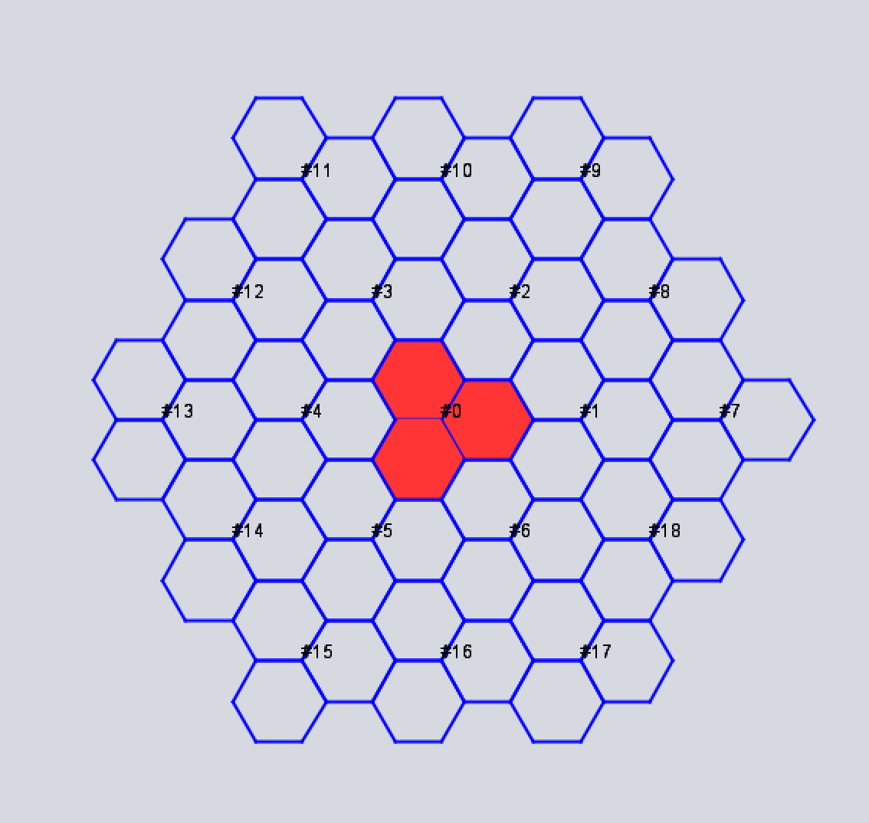

A4.2.3 Propagation models used in this study
Recommendation ITU-R P.452-18 (08/2023) – Prediction procedure for the evaluation of interference between stations on the surface of the Earth at frequencies above about 100 MHz – will be used with terrain and clutter heights around the Sagamore Hill, MA solar flux monitor site to derive the statistics of the path losses from the IMT base station sectors that are active for each sample in the Monte Carlo simulation.

A4.3 Methodology
The parameters and IMT macro cell/network geometry summarized in Section A4.2.2, and the propagation modeling outlined in Section A4.2.3 above will be used to study out-of-band emissions of IMT downlinks operational in the adjacent band within the power flux density threshold of currently operating solar flux monitors.

International Civil Aviation Organization, Manual on Space Weather Information in Support of International Air Navigation. Its final draft can be retrieved from: https://www.icao.int/airnavigation/METP/Panel Documents/Doc.10100.Space Weather Manual FINAL DRAFT Version.pdf.

